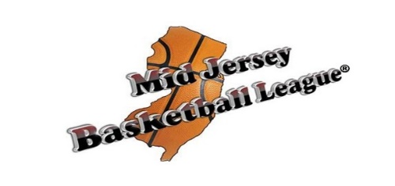
Monroe Sports Center/Central Jersey Basketball
Independent Team Information Form

Team Name: ___________________ Coach: _________________ Coach Email:_________________________

Team Organizer: ___________________________ Phone: ___________ Email:________________________

Number of Practices ______ (reg season is 12-13 weeks long)
(full court: $110/hr, half court: $70/hr, CJB full practice court $80/hr)

Number of MJBL Games _________
(14 games: $1,430, 12 games: $1,250, 10 games: $1050, 8 games: $850)

Tournaments ____________________________________________________________________________
List Tournament Name & Number of Games

Invoice players individually (Y or N) _____ Include Coach Pay in invoices (Y or N): _____ Coach Rate/Hr: ____
If no, who should invoice be sent to________________________

Practices: Day of Week___________ Time___________ Half or Full Court _________ Location ___________
If your team practices vary from week to week, please list the practice dates below:

Practice Dates (based on availability): __________________________________________________________
Summer MJBL regular season begins Sat Jun 17 and ends around Fri Sep 8, 2023.

Additional Comments: _______________________________________________________________________

Uni # | Player Name | Birth Date | Grade | Phone | Email

Please submit FULLY COMPLETED form to basketball@monroeportscenter.com or to the desk at MSC or CJB

